INTRODUCTION

* 1. OVERVIEW

India is the world's third-largest producer and third-largest consumer of electricity. The national electric grid in India has an installed capacity of 370.106 GW as of 31 March 2020. Renewable power plants, which also include large hydroelectric plants, constitute 35.86% of India's total installed capacity. During the fiscal year (FY) 2019–20, the total electricity generation in the country was 1,598 TWh, of which 1,383.5 TWh generated by utilities. The gross electricity consumption per capita in FY2019 was 1,208 kWh.

In 2015-16, electric energy consumption in agriculture was recorded as being the highest (17.89%) worldwide. The per capita electricity consumption is low compared to most other countries despite India having a low electricity tariff.

In light of the recent COVID-19 situation, when everyone has been under lockdown for the months of March to June the impacts lockdown

Analysing Electricity Consumption in India from Jan 2019 till 5th December 2020. This dataset contains a record of Electricity consumption in each states of India, here we are going to analyse State wise , Region wise and Overall Electricity consumption in India.

* 1. Purpose

The business requirements for analyzing analysis on electricity consumption in IndiaIdentify the current patterns of electricity consumption in different regions and sectors of India. This information can be used to identify areas where consumption is high and areas where it is low. Identify opportunities for improving energy efficiency and reducing consumption in different sector regions. This information can be used to develop policies and programs to promote energy efficiency. This information can be used by government agencies, electricity providers, and investors to develop policies and make investment decisions that promote sustainable energy development and consumption in India

1. PROLBLEM Defintion & Design Thinking

2.1 Empathy Map

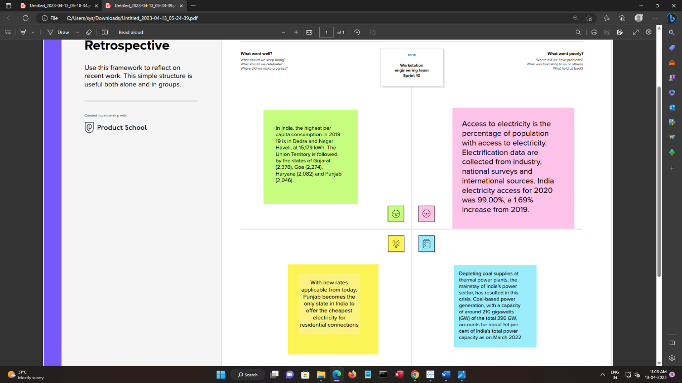

2.2 ideation & Brainstorming map screeshot

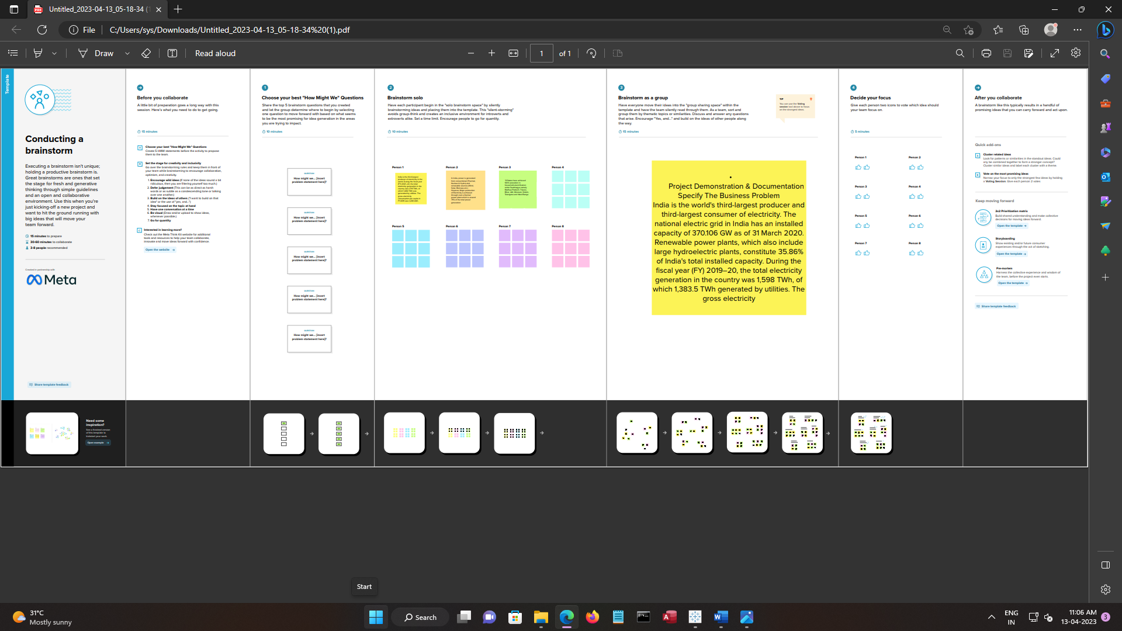

**3.RESULT**

3.1DASHBOARD

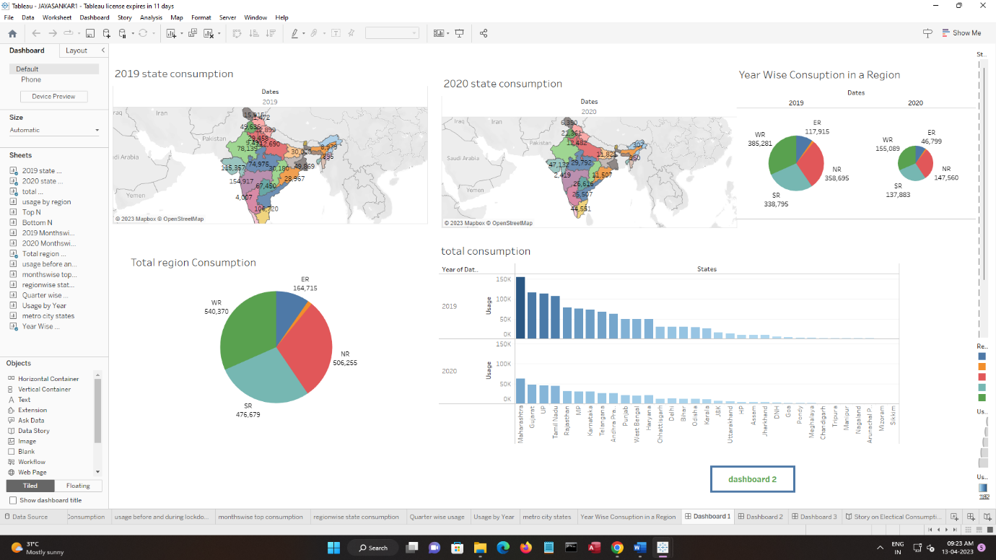

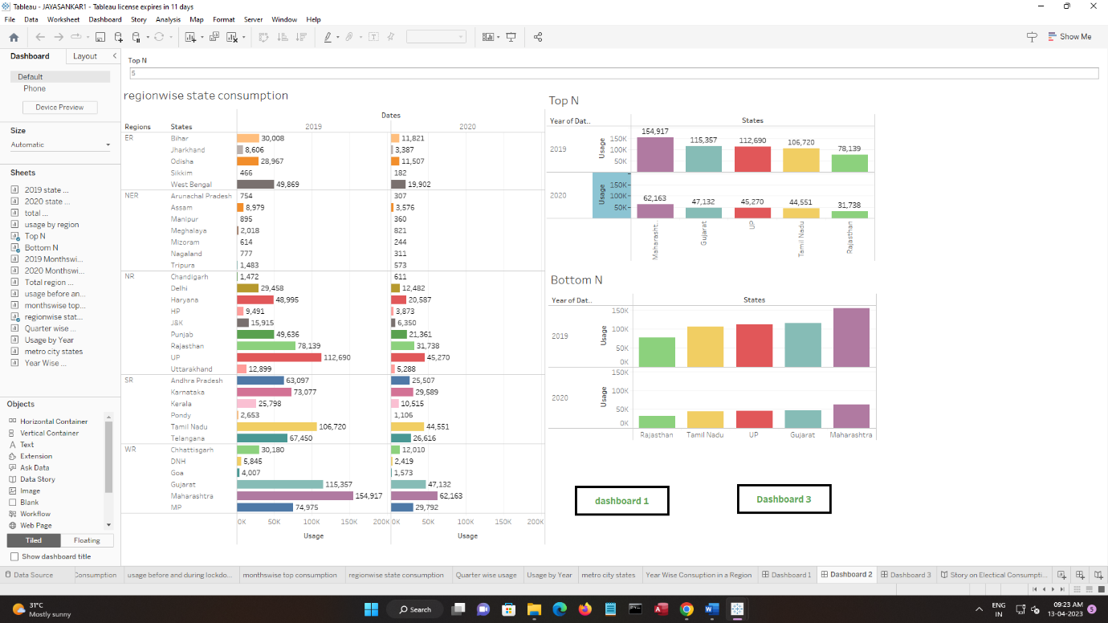

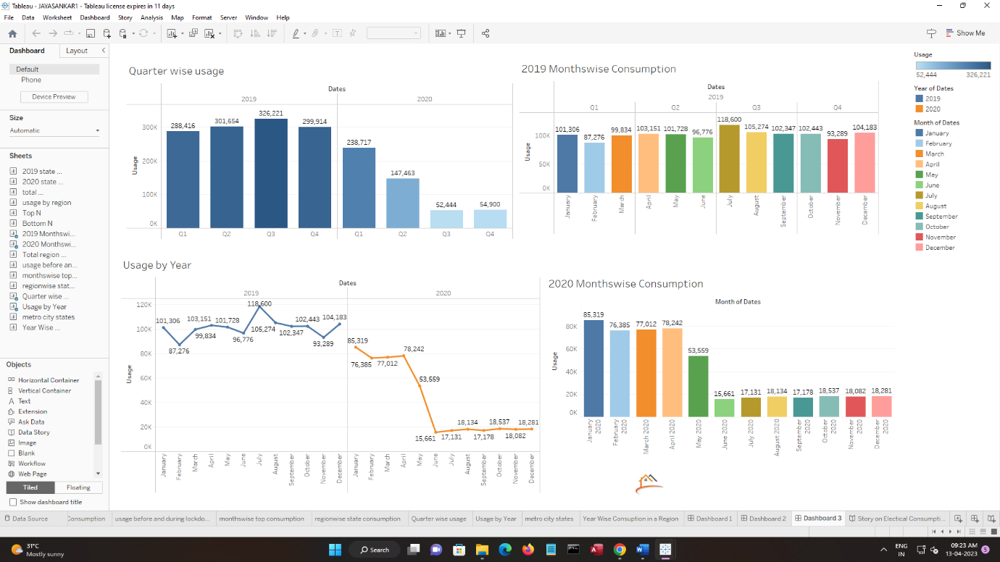

3.2 STORY

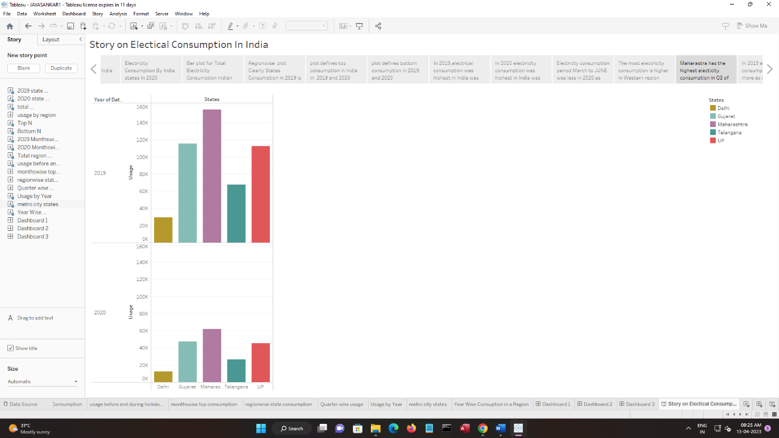

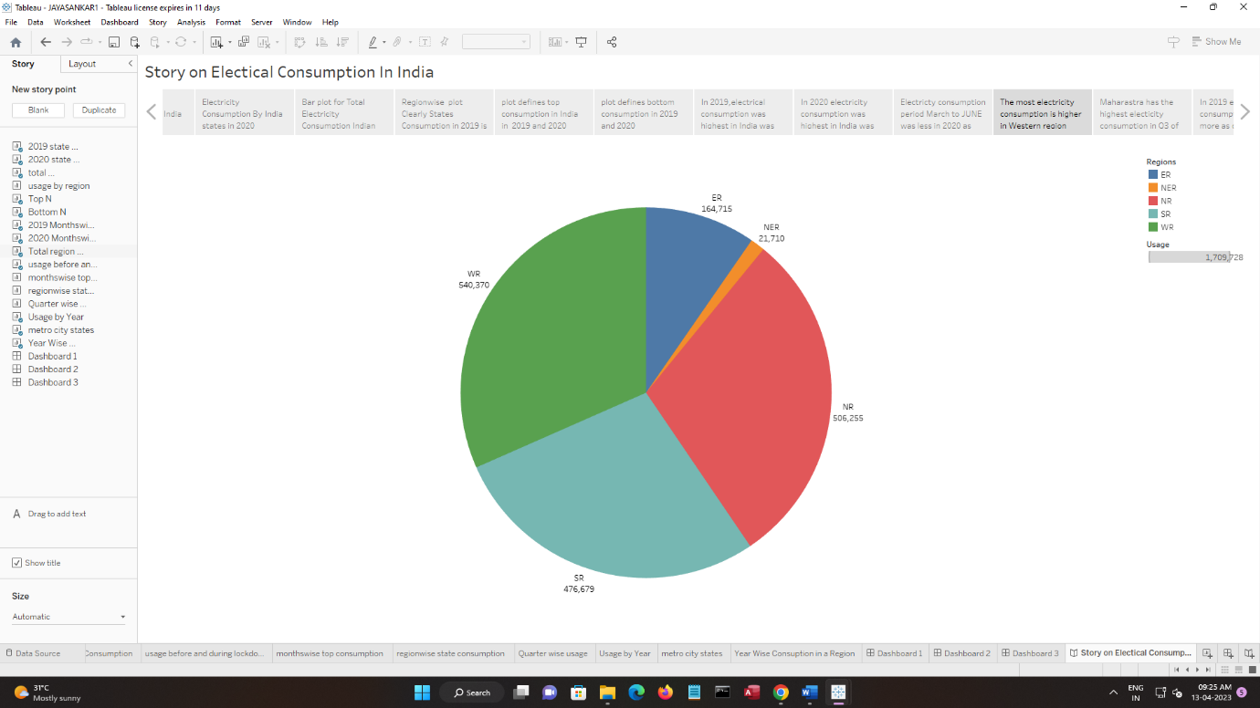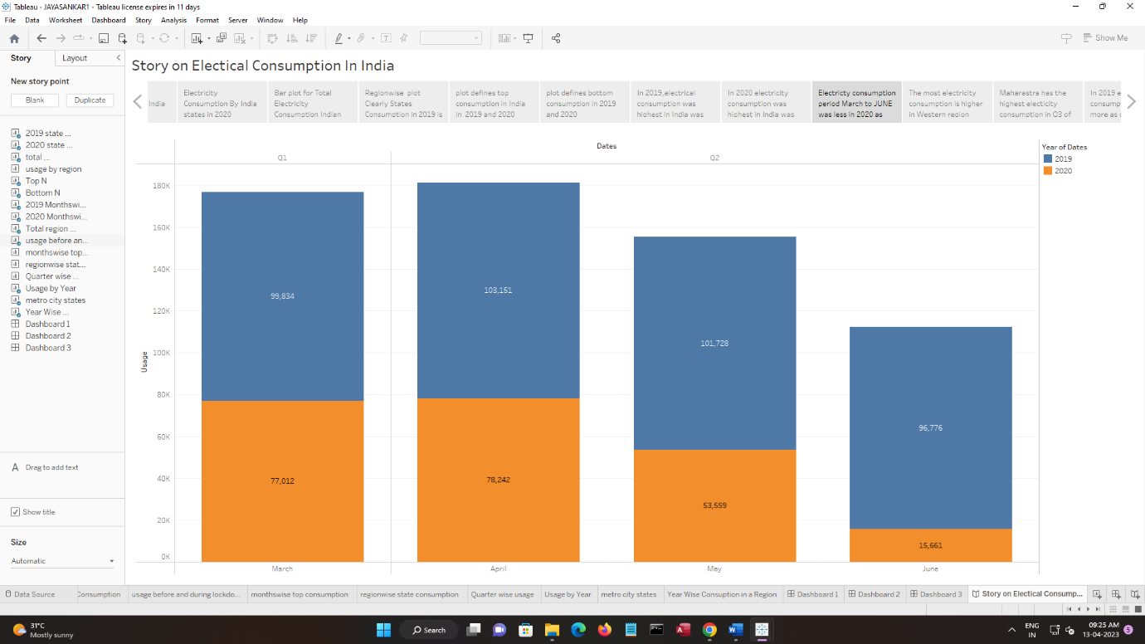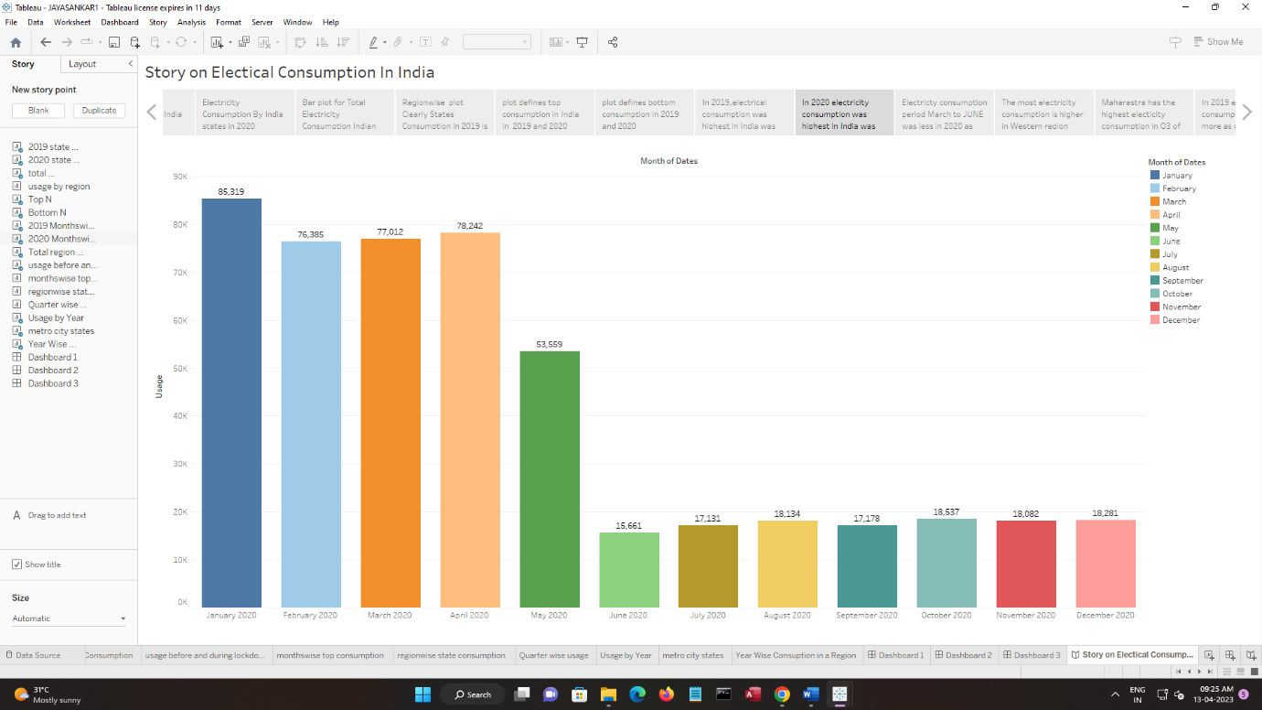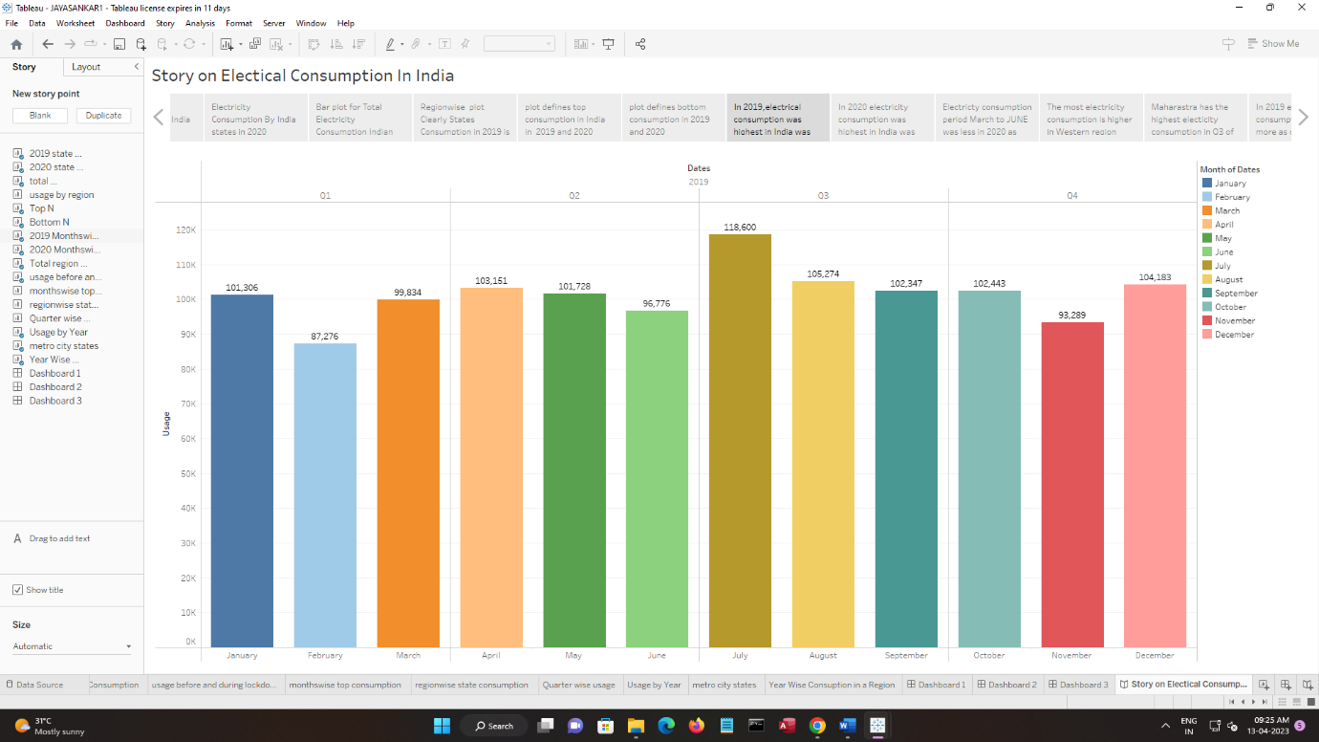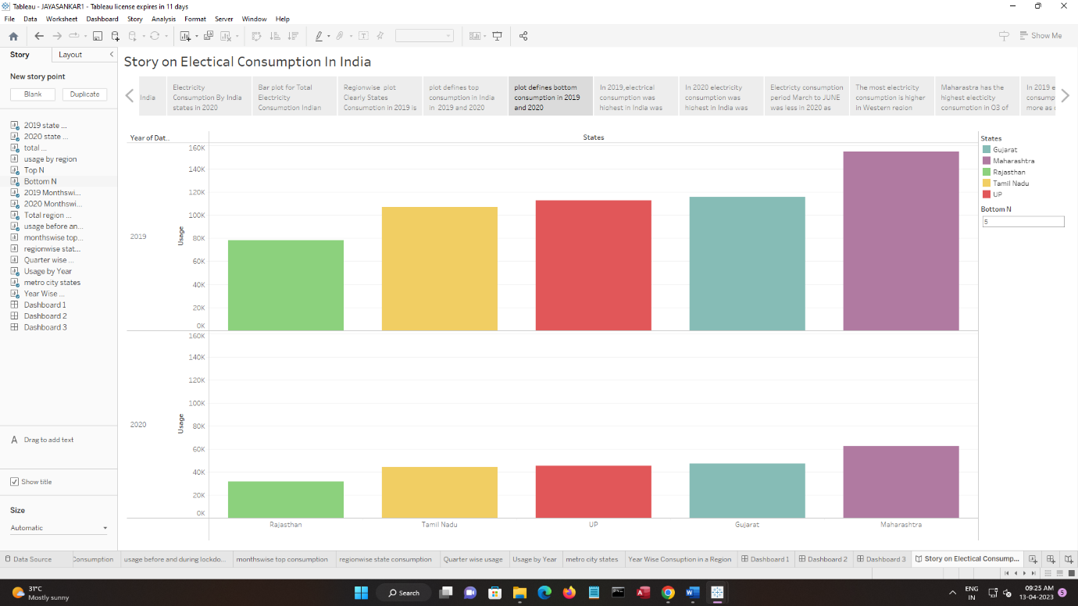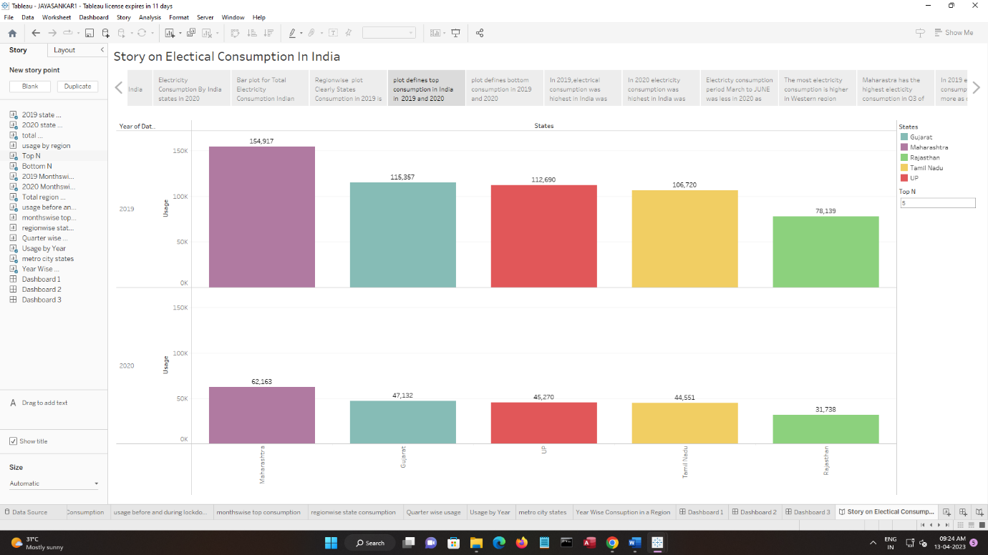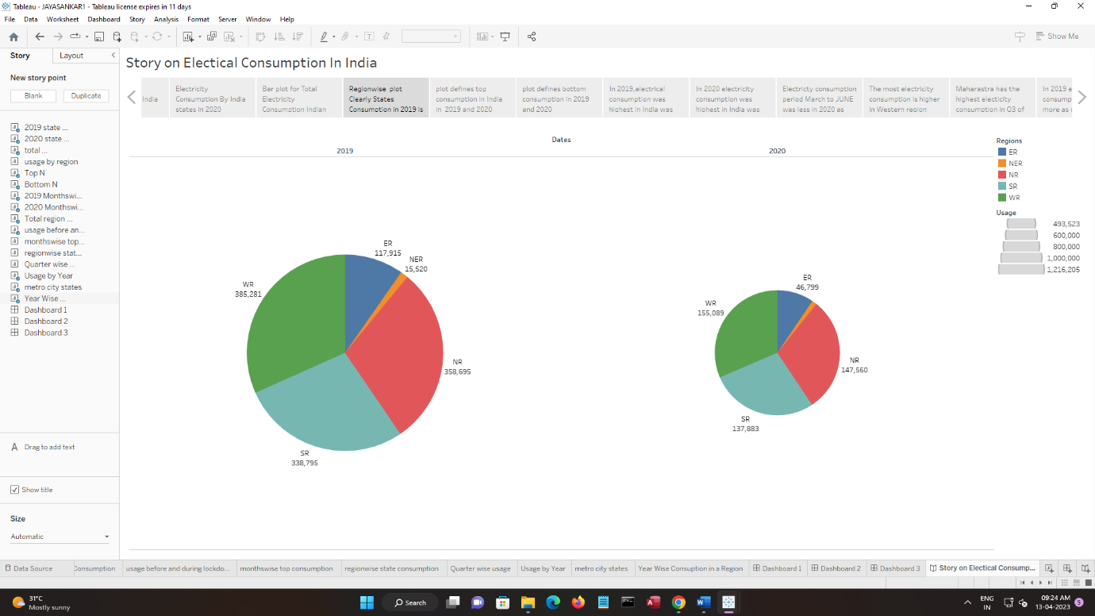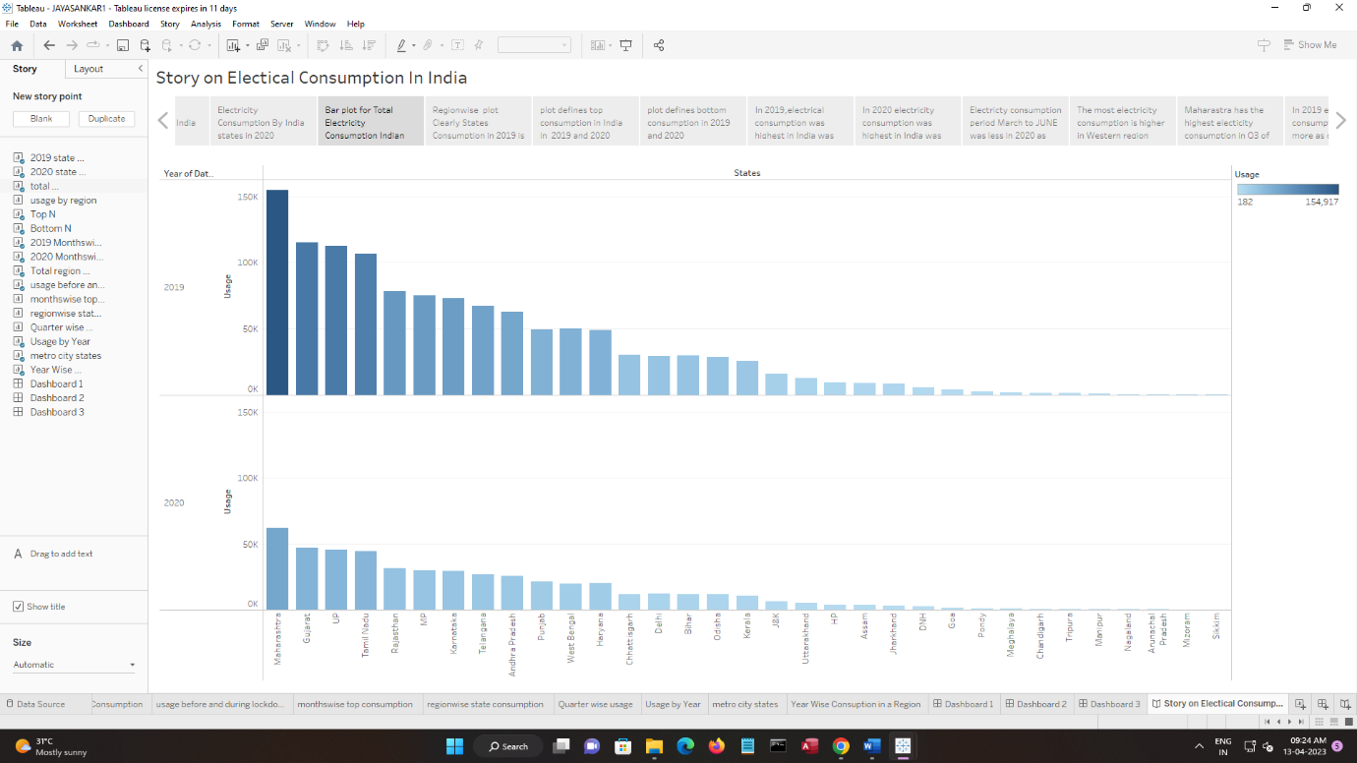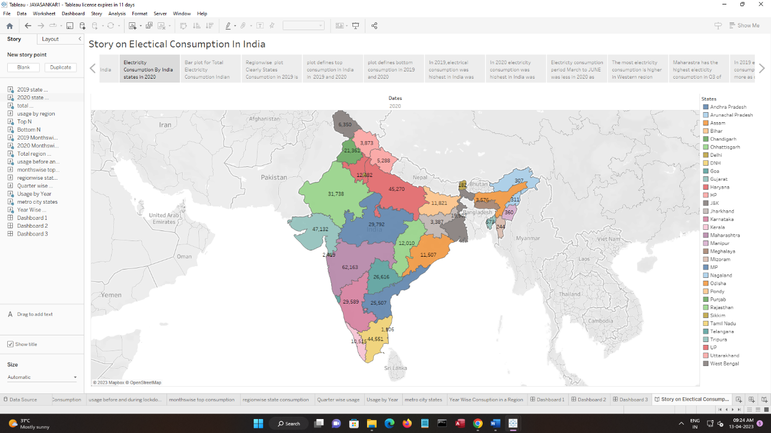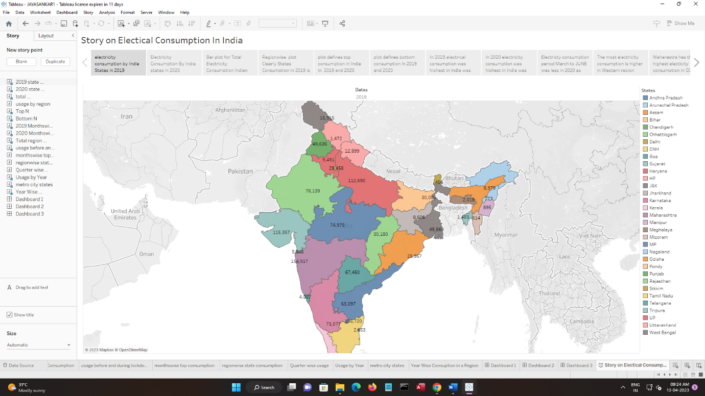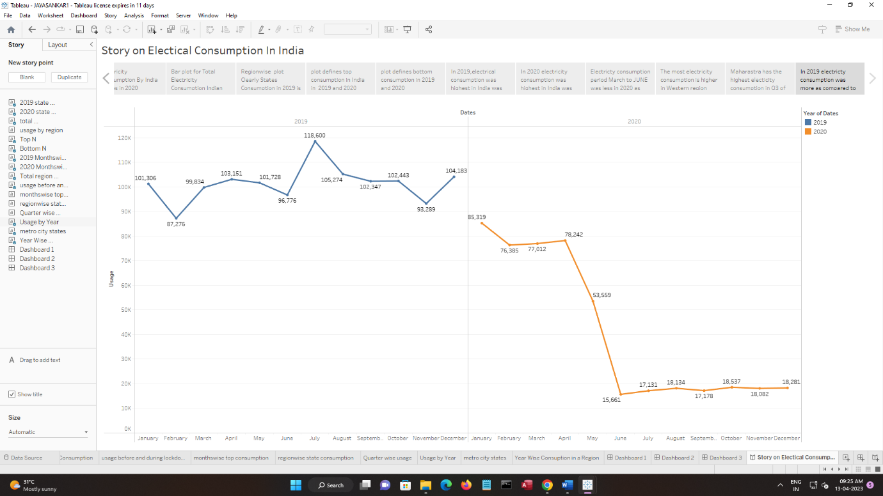

In Dataset Consumption.csv data is in the form of a time series for a period of 24 months beginning from 2nd Jan 2019 till 5th December 2020. Columns contains States, Regions, Latitude, Longitude, Dates andUsage. The dataset has been scraped from the weekly energy reports of POSOC.

Fields Include

                          States - Indian States

                          Regions- States in Regions on Indian Map

                          Latitude - States in Regions on Indian Map

                          Longitude - Geographical Coordinates of States

                          Dates - Dates of Usage

                          Usage - Power consumed in Mega Units(MU)

4.ADVANTAGES & DISADVANTAGES

Social Impact: By providing access to electricity, the analysis can help to improve the quality of life for people living in areas without access to electricity, including providing access to lighting, heating, and cooling, and powering essential services such as hospitals and schools..

Business Model/Impact: By understanding consumption patterns and trends, the analysis can help businesses identify market opportunities and develop strategies to meet the growing demand for electricity in India

5.APPILCATIONS

Preparing the data for visualization involves cleaning the data to remove irrelevant or missing data, transforming the data into a format that can be easily visualized, exploring the data to identify patterns and trends, filtering the data to focus on specific subsets of data, preparing the data for visualization software, and ensuring the data is accurate and complete. This process helps to make the data easily understandable and ready for creating visualizations to gain insights into the performance and efficiency.

This data is preprocessed initially. Lets proceed for visualization.

6.CONCLUSION

* In This Project the states dataset is sparated to the different graphs,barchart,piechart,etc…,according to people sunder stand the dataset by seeing the chats and stories.in project the 2019 is highest sates seeling year in dataset collection.
* The project visualization/Graphs are given below

States - Indian States

* Regions- States in Regions on Indian Map
* Latitude - States in Regions on Indian Map
* Longitude - Geographical Coordinates of States
* Dates - Dates of Usage
* Usage - Power consumed in Mega Units(MU)

7 Future Scope

* The number of unique visualizations that can be created with a given dataset. Some common types of visualizations that can be used to analyze the performance and efficiency of Radisson Hotels include bar charts, line charts, heat maps, scatter plots, pie charts,Maps etc.
* These visualizations can be used to compare performance, track changes over time, show distribution, and relationships between variables, breakdown of revenue and customer demographics, workload, resource allocation and location of hotels.

8 APPENDIX

### A.SOURCE CODE

<https://public.tableau.com/views/JAYASANKAR1/StoryonElecticalConsumptionInIndia?:language=en-GB&publish=yes&:display_count=n&:origin=viz_share_link>

DASHBOARD

<https://public.tableau.com/shared/74FH5ZS2G?:display_count=n&:origin=viz_share_link>

<https://public.tableau.com/views/JAYASANKAR1/Dashboard2?:language=en-GB&publish=yes&:display_count=n&:origin=viz_share_link>

<https://public.tableau.com/views/JAYASANKAR1/Dashboard3?:language=en-GB&publish=yes&:display_count=n&:origin=viz_share_link>